 Art Document

Document Issue: 1.0 Document Status: In Progress
Date Issued: Jan 18, 2002 Filing Path: D:\simpsons2\documents\art

Last Updated: May 28th, 2002 (by Sarah Meagher)

Document Title: Texture Naming Convention and PSD Organization

Author: Kevin Fink

Naming Convention:

Generic Buildings:

(Color)_(Style).(File Extension)
e.g. Pnk_A.Bmp

Color: Maximum 3 characters describing the base color.
Style: A-F

A – Blank/Base texture
B – Door
C – Window
D – Window (second style)
E – Special Building feature
F – Top Floor*

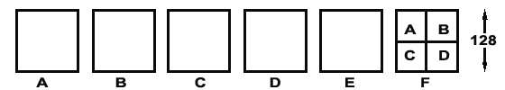

* The Top Floor (F) is one 128 x 128 texture divided into four 64 x 64 sub-textures. The four sub-textures should follow the same lettering system as the larger textures, except on the second floor the door (B) can be replaced by a third window type.

Naming Convention Continued:

Landmarks:

(Building Name)_(Type)_(Style).(File Extension)
e.g. Pol_Win_A.Bmp

Building Name: Maximum 3 characters describing name of building
Type: Maximum 3-4 letter description of the texture (e.g. window, roof, etc.)
Style: Letter representing different styles of the same Type

The same concept of all second floor textures being a sub-texture of a map 128 x 128 applies to landmarks.

Props:

(Prop name)_(Style)(x*).(File Extension)
e.g. StrtLmp_A.bmp
e.g. StrtLmp_Ax.Bmp
Prop name: Maximum 10 characters describing prop
Style: Letter representing different textures on the same Prop name
X: represents alpha channel

*If applicable.

Bit Depth (Colors & Alphas):

8bit .bmp format – 256 colors, with possible 4bit alpha
When making a BMP, copied from the PSD layered version of a texture, reduce it to 256 colors. If the texture requires an alpha, make sure it is black & white only, not grayscale. The alpha must be a separate image (BMPs don’t support an embedded alpha channel anyway), with (?white?) representing the transparent section. It is then added under the material attributes >> transparency.
***Please refer to naming convention above.
(Later we may reduce a few simpler textures to 4bit - 16 colors).

Note (May 28th, 2002):
Unfortunately, this separate alpha format is not visible in Maya’s hardware rendering. You can render out an image - but the transparency may be inverted, since Maya disagrees with Photoshop on whether black or white is transparent. Once we see alpha’d materials in game, we can determine whether black or white should be transparent in an alpha coming out of Photoshop, or maybe get a simple P3D solution. The best option is to export your object or scene to the game/previewer in order to see the transparency.

Material Templates

These are PSD samples, to be used as reference whenever creating textures for woods or metals (more materials to be added later). For example: all light wood, like pine, will look consistent, as will dark metals, etc. This is a sample of the path where the material templates can be found:

//depot/Art/SourceImages/Global/material_templates/woods/pine.psd

(May 28th, 2002: A sample image will be added here ASAP)

PhotoShop Layer Sets:
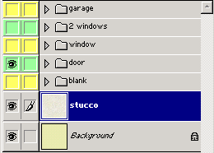

All Layer Sets are labeled as to their content and the Layer Set Color alternates between green and yellow to easily distinguish between them. Any detail to the texture that is global (i.e. stucco) can be placed outside of the Layer Sets and maintains consistency throughout the textures.

Photoshop Layers:

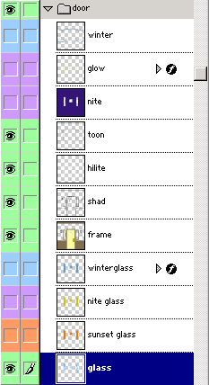
All Layers are labeled as to their content and share the color of the Layer Set.
There are typically five Layers to a texture, not including the Background Layer that is the base color. The fewer layers you have the easier it is to interpret if your work is handed off to someone else.

- Glass – Generic blue window including any reflections and streak details included.
- Frame – Any detail specific to that Layer Set. (Window frame, doors, etc).
- Shadow – Drawn using pure black, layer opacity between 30 – 40 % depending on Background color.
- Hi-light – Drawn using pure white, layer opacity between 30 – 40 % depending on Background color.
- Toon – Drawn using pure black with the line tool at 1px width and anti-aliasing checked, layer opacity between 40 – 50 % depending on Background color. The goal is to create a hand drawn look so the less perfect the line looks the better. Erasing parts of the line with a splotchy eraser in conjunction with the liquefy tool is effective in achieving this look.
- Special Layers:

When changing the look of the texture (e.g. time of day or seasonal changes) the Layer Color follow these rules:

Look Layer Color

Night Purple

Sunset Orange
Special Blue
Special Red

File Structure :

